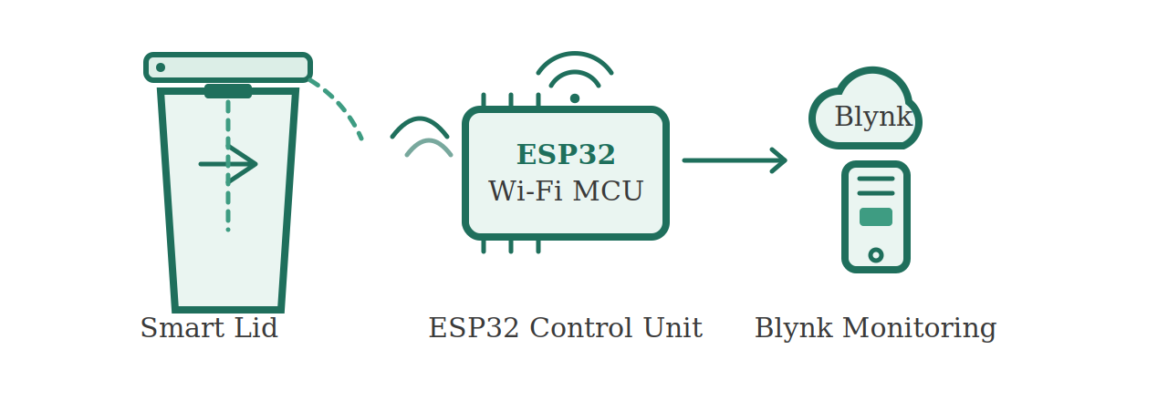
SMART BIN
IoT-Based Automatic Lid Dustbin using ESP32 and Blynk
Project Documentation

Project by: M. Jayantha Siva Srinivas
B. Tech, Electronics and Communication Engineering
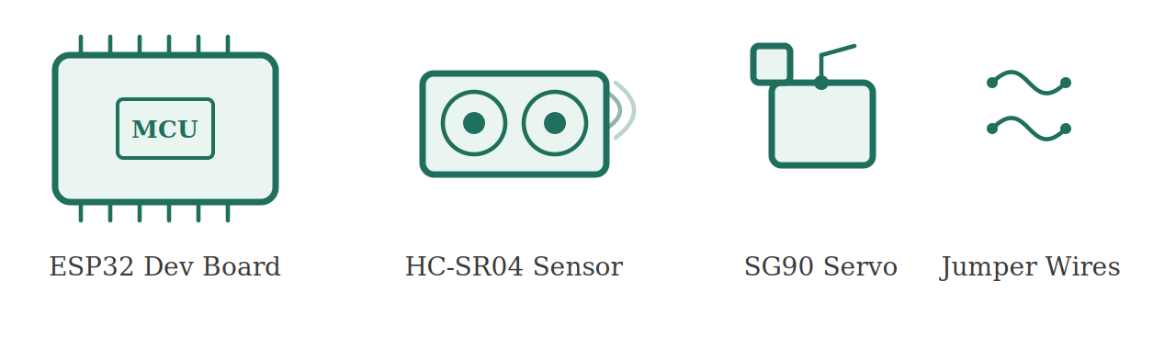

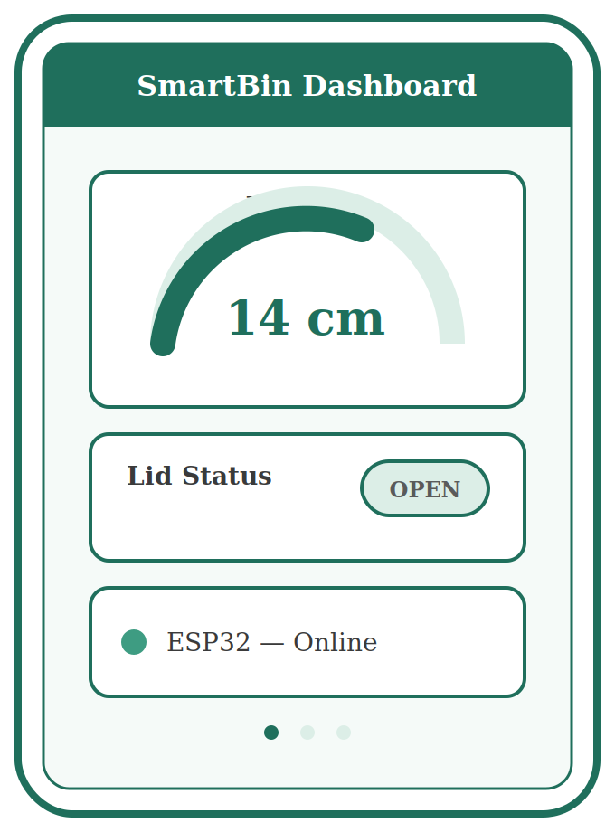
Blynk IoT

1. Project Overview
Smart Bin is an IoT-enabled waste bin that automatically opens its lid when an object or hand approaches it, and reports its live status to a mobile/web dashboard in real time. The system uses an ultrasonic distance sensor to detect proximity, a servo motor to actuate the lid, and an ESP32 microcontroller to run the logic and push data to the cloud through the Blynk IoT platform.
The goal of the project was to build a low-cost, contactless, internet-connected dustbin that eliminates the need to physically touch the lid, while also giving the user a way to remotely monitor the bin's lid status and the distance reading from anywhere through the Blynk dashboard.

1.1 Key Features
- Contactless, automatic lid opening using ultrasonic proximity sensing.
- Real-time distance visualization on a Blynk Gauge widget.
- Real-time lid status (OPEN / CLOSED) visualization on a Blynk Label widget.
- Wi-Fi connectivity via the ESP32's built-in module — no extra networking hardware.
- Cloud dashboard accessible from anywhere, on mobile or web.
- Simple, low-cost hardware — no display module required on the device itself.

2. Hardware and Software Components

2.1 Hardware Used
- ESP32 Development Board (Wi-Fi + Bluetooth microcontroller)
- HC-SR04 Ultrasonic Distance Sensor
- SG90 Micro Servo Motor (lid actuator)
- Jumper wires and breadboard
- USB cable for power and programming
- Bin enclosure / prototype housing

2.2 Software and Platforms Used
- Arduino IDE — used to write and upload ("flash") the firmware to the ESP32.
- Blynk IoT platform (Blynk Console) — cloud dashboard for visualization and monitoring.
- ESP32 Arduino core, plus the Blynk and ESP32Servo libraries.

2.3 Pin Connection Table
Component | Pin / Signal | ESP32 GPIO
HC-SR04 Ultrasonic Sensor | TRIG | GPIO 5
HC-SR04 Ultrasonic Sensor | ECHO | GPIO 18
SG90 Servo Motor | Signal (PWM) | GPIO 13

3. Hardware Setup
The ultrasonic sensor is mounted facing outward/upward on top of the bin's lid assembly so it can detect an approaching hand or object. The servo motor is coupled to the lid mechanism so that it can swing the lid open on command. The ESP32 board is powered over USB and connects to the local Wi-Fi network to communicate with the Blynk cloud server.

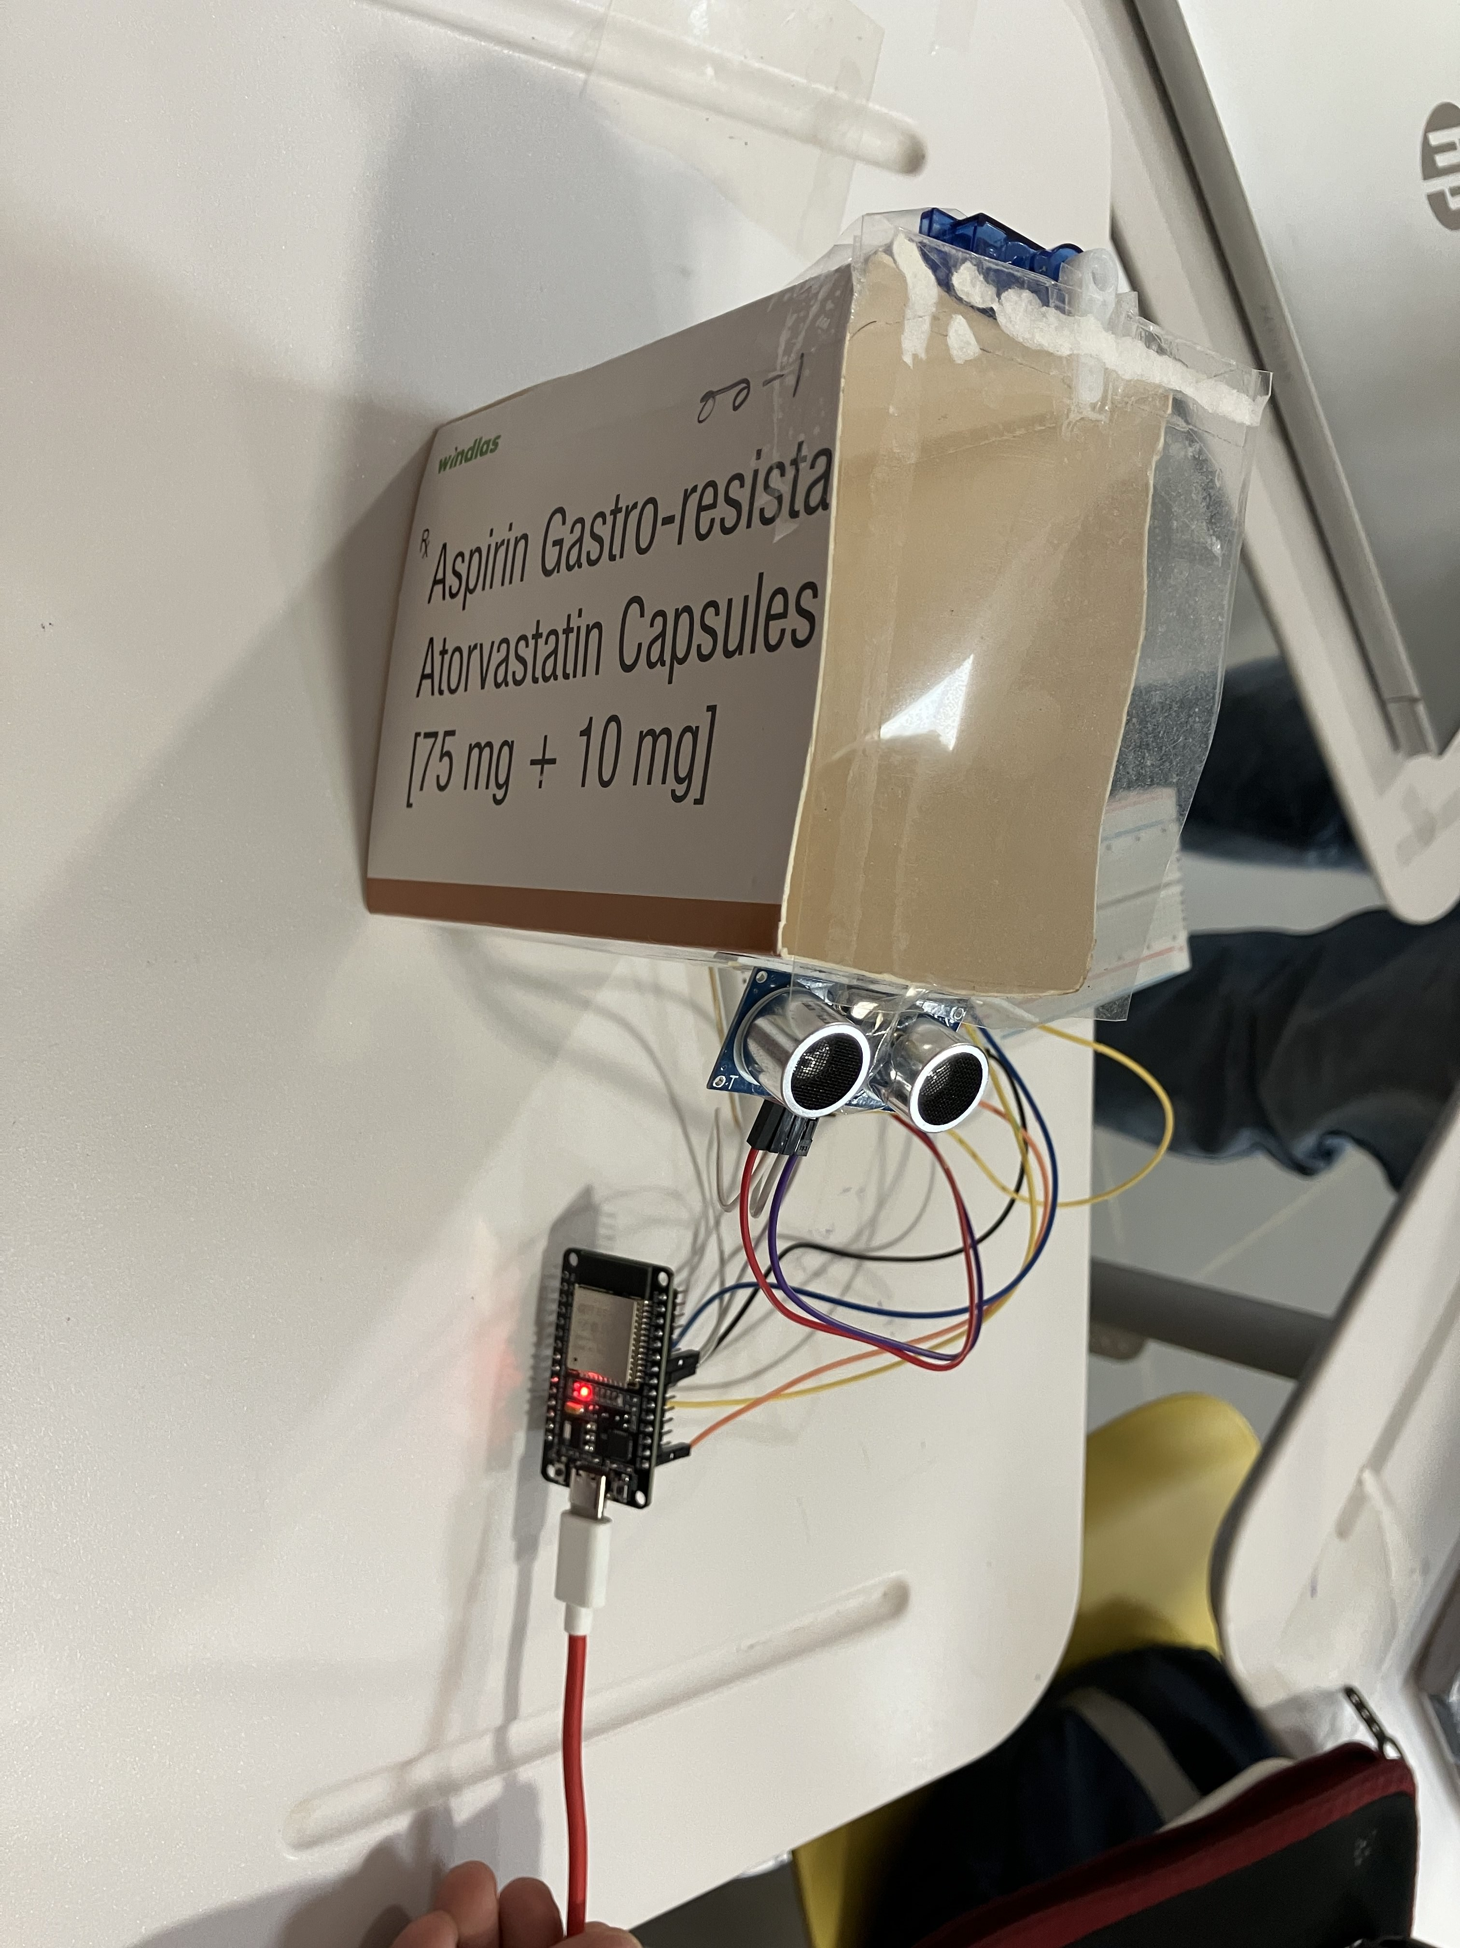
Fig. 1 — Prototype hardware setup: ESP32 board, HC-SR04 ultrasonic sensor, and wiring mounted on the bin enclosure

4. Working Principle
- The HC-SR04 sensor continuously measures the distance to the nearest object in front of the bin by timing an ultrasonic pulse's echo.
- The ESP32 reads this distance every second using a Blynk timer.
- If the measured distance is less than or equal to 20 cm (and greater than 0), the ESP32 treats this as "an object/hand is present" and rotates the servo to 90° to open the lid.
- If the distance is greater than 20 cm, the servo returns to 0°, closing the lid.
- On every reading, the ESP32 pushes the live distance value to virtual pin V0 (displayed on a Gauge widget) and the lid status text ("OPEN" or "CLOSED") to virtual pin V1 (displayed on a Label widget) on the Blynk dashboard.
- Because the ESP32 stays connected to Wi-Fi and the Blynk cloud, this status can be viewed live from any device running the Blynk app or console, without being physically near the bin.

5. Blynk IoT Dashboard
The dashboard was built in the Blynk Console under a device named "SmartBin", using two widgets:
- Gauge widget (V0) — displays the live ultrasonic distance reading in centimetres, scaled 0–100.
- Label widget (V1) — displays the current lid status as the text "OPEN" or "CLOSED".

5.1 Lid Closed State
When no object is within range, the distance reads close to 100 cm and the Label widget shows "CLOSED".
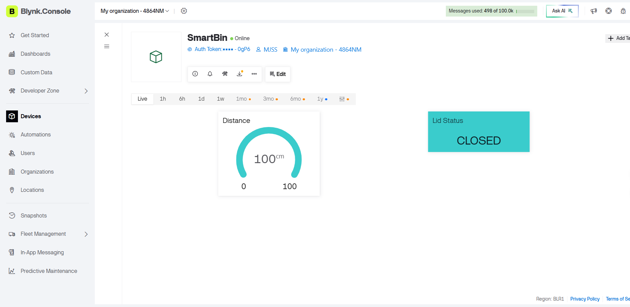
Fig. 2 — Blynk dashboard: Distance gauge reads 100 cm, Lid Status shows CLOSED

5.2 Lid Open State
When an object/hand comes within the 20 cm threshold, the distance reading drops and the Label widget updates to "OPEN" in real time.
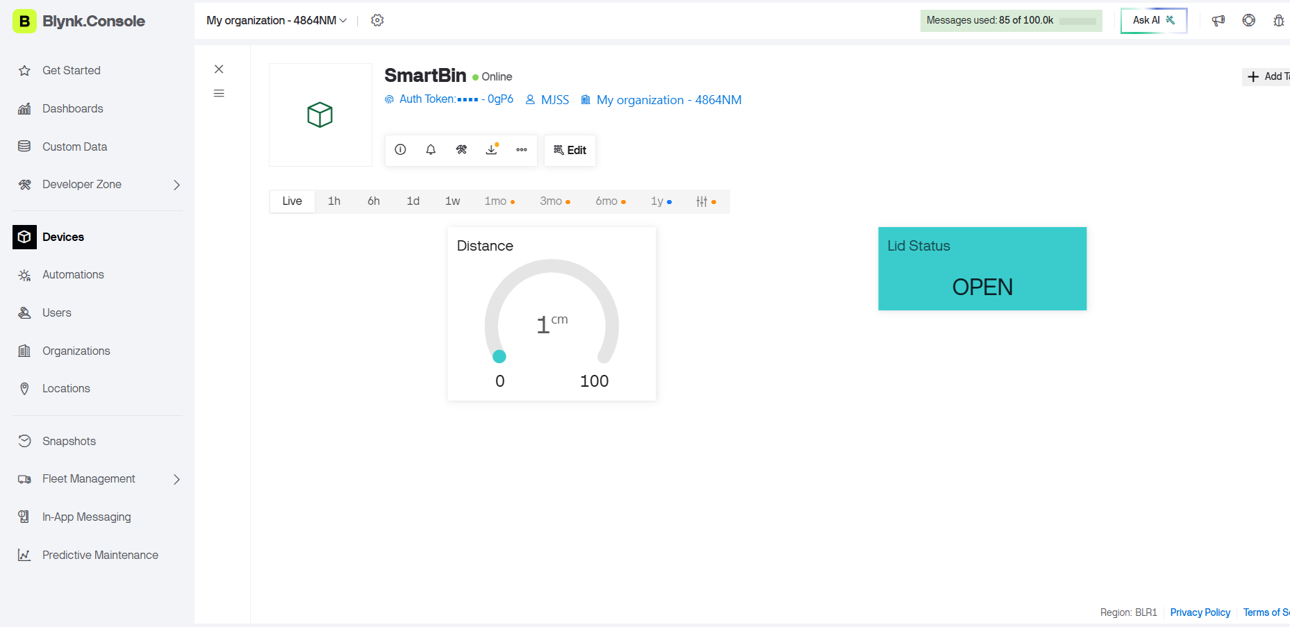
Fig. 3 — Blynk dashboard: Distance gauge reads 1 cm, Lid Status shows OPEN

6. Firmware (Arduino IDE, ESP32)
The firmware below is written for the Arduino IDE and flashed onto the ESP32. It reads the HC-SR04 sensor, drives the SG90 servo, and streams the distance and lid-status values to the Blynk Gauge and Label widgets. Unlike the original working draft, this version has the OLED display code fully removed, since the project's status output is handled entirely through the Blynk dashboard rather than an on-device screen.
#define BLYNK_TEMPLATE_ID "TMPL3LvNQJAGE"
#define BLYNK_TEMPLATE_NAME "SmartBin"
#define BLYNK_AUTH_TOKEN "3Qsw7VqnMGUbOJbYLbQTm-YHN6Xe0gP6"

#include <WiFi.h>
#include <BlynkSimpleEsp32.h>
#include <ESP32Servo.h>

// ---------- WiFi credentials ----------
char ssid[] = "Jay";
char pass[] = "MSP@1978";

// ---------- Pin definitions ----------
#define TRIG_PIN 5
#define ECHO_PIN 18
#define SERVO_PIN 13

Servo lidServo;
bool lidOpen = false;
BlynkTimer timer;

void sendSensor()
{
long duration;
float distance;

// Trigger the ultrasonic sensor
digitalWrite(TRIG_PIN, LOW);
delayMicroseconds(2);
digitalWrite(TRIG_PIN, HIGH);
delayMicroseconds(10);
digitalWrite(TRIG_PIN, LOW);

duration = pulseIn(ECHO_PIN, HIGH);
distance = duration * 0.0343 / 2;

Serial.print("Distance : ");
Serial.println(distance);

if (distance <= 20 && distance > 0)
{
lidServo.write(90);
lidOpen = true;
Blynk.virtualWrite(V1, "OPEN");
}
else
{
lidServo.write(0);
lidOpen = false;
Blynk.virtualWrite(V1, "CLOSED");
}

// Send distance reading to the Blynk Gauge widget
Blynk.virtualWrite(V0, distance);
}

void setup()
{
Serial.begin(115200);

pinMode(TRIG_PIN, OUTPUT);
pinMode(ECHO_PIN, INPUT);

lidServo.setPeriodHertz(50);
lidServo.attach(SERVO_PIN, 500, 2400);
lidServo.write(0);

WiFi.begin(ssid, pass);
while (WiFi.status() != WL_CONNECTED)
{
delay(500);
Serial.print(".");
}
Serial.println("WiFi Connected");

Blynk.begin(BLYNK_AUTH_TOKEN, ssid, pass);
timer.setInterval(1000L, sendSensor);
}

void loop()
{
Blynk.run();
timer.run();
}

7. Testing and Results
- Uploaded the firmware to the ESP32 via Arduino IDE and confirmed a successful Wi-Fi connection over Serial Monitor.
- Verified the device came Online in the Blynk Console under the Smart Bin template.
- With no object nearby, confirmed the Gauge showed a distance near 100 cm and the Label showed CLOSED.
- Bringing a hand within ~20 cm of the sensor triggered the servo to open the lid, the Gauge dropped to a low reading (as low as 1 cm), and the Label updated to OPEN in real time.
- Confirmed the dashboard updated live, once per second, matching the Blynk Timer interval in firmware.

8. Future Scope
- Add a fill-level sensor (a second ultrasonic sensor inside the bin) to warn when the bin is nearly full, with a Blynk notification/alert.
- Add a battery + solar charging circuit for fully wireless, outdoor-ready operation.
- Introduce waste segregation using a moisture sensor and a diverter flap to separate dry and wet waste automatically.
- Add a buzzer for local audible alerts (e.g., bin full, lid stuck) in addition to the cloud dashboard.
- Log historical distance/usage data in Blynk to analyze bin usage patterns over time.
- Move to a more power-efficient duty cycle (deep sleep between readings) to extend battery life in a portable version.
- Scale to a fleet of bins across a location, each reporting to the same Blynk organization dashboard for centralized municipal or campus-wide monitoring.

9. Knowledge Gained
- Practical experience interfacing an HC-SR04 ultrasonic sensor with an ESP32 and converting echo pulse duration into a real-world distance value.
- Hands-on control of an SG90 servo motor using the ESP32Servo library, including setting PWM period and pulse-width range for accurate angle control.
- End-to-end IoT integration: connecting an ESP32 to Wi-Fi, authenticating with the Blynk cloud, and streaming sensor data to virtual pins in real time.
- Working with Blynk IoT dashboard widgets — configuring a Gauge and a Label widget and mapping them to virtual pins (V0, V1).
- Using Blynk Timer to run periodic, non-blocking sensor reads instead of blocking delay() calls in the main loop.
- Debugging and cleaning up firmware — identifying and fixing a broken string literal in the Wi-Fi credentials, and removing display-related code and its dependent libraries cleanly without breaking the rest of the logic.
- Understanding the trade-off of removing a local display: the project now depends fully on network connectivity for status visibility, which is a useful design lesson in remote vs. on-device feedback.
- General workflow of flashing firmware from Arduino IDE to an ESP32 and validating behaviour against a live cloud dashboard.

10. Project Video

Note: Double Click on above file to open Video.

— End of Document —

